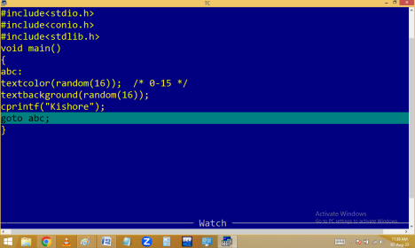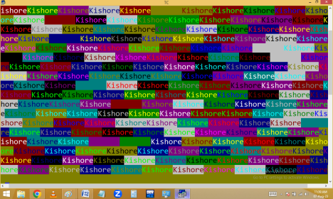
IF CONDITIONAL STATEMENT:
If is a keyword.
It is a decision making statement.
It is used to check the given condition is true or false. Based on the condition result it is taking a decision that it have to be execute the statements or not if block { }.
If( condition )
{
Block;
}
Note: In C 0 means false and other than 0 anything is true i.e. 1
In C we are using 4 types of if conditions.
1. Simple if
2. If….else
3. If…else if ladder
4. Nested if
Simple if: When the program is having one condition then go for simple if.
If condition true then statements in if block { } are executed and later outside statements also executed.
If condition false only the outside statements executed.
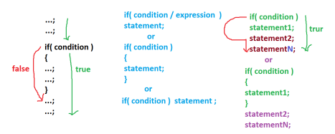
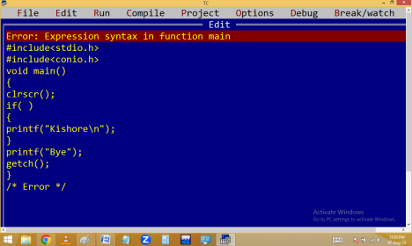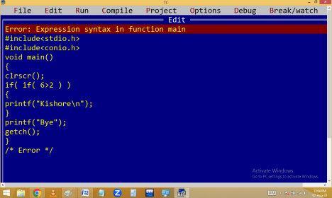
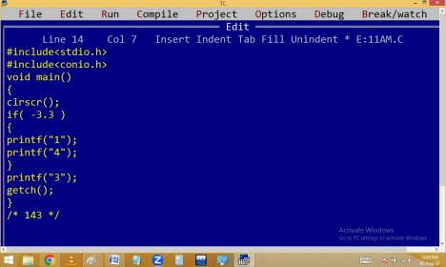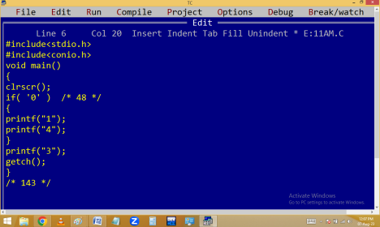
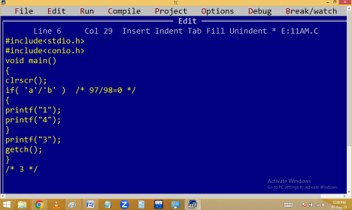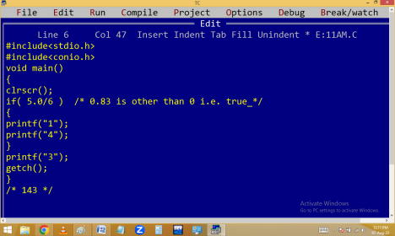
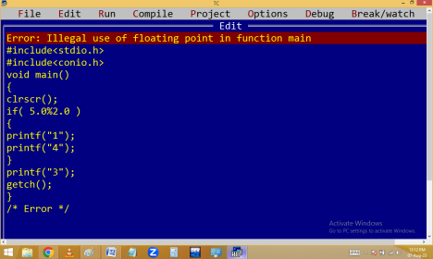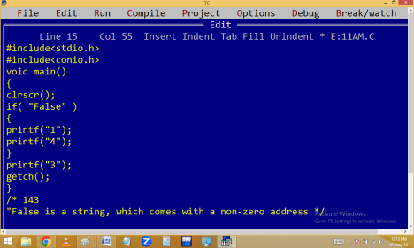
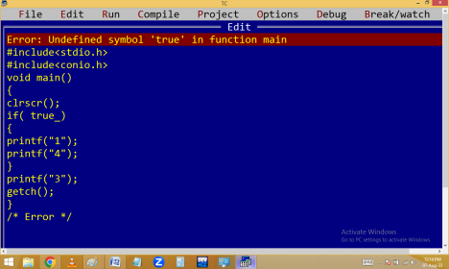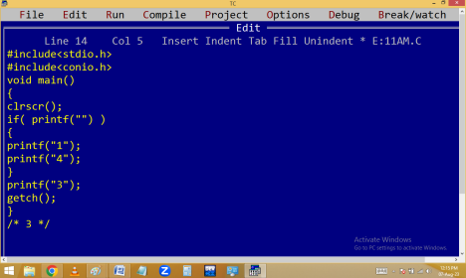
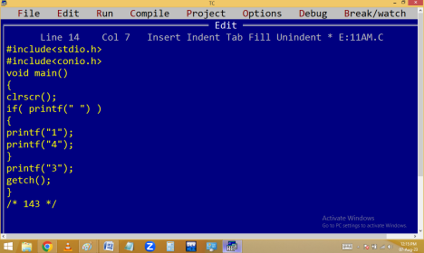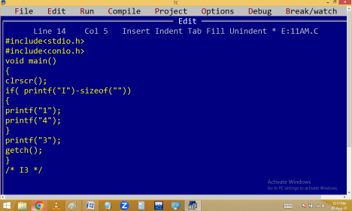
Write a c program to print your name without using semicolon.

